**Git lap configuration on Ubuntu latest**

Lunch the EC2 instance type is large DBS 8 GB.

1. Install and configure the necessary dependencies

* + sudo apt-get update
  + sudo apt-get install -y curl openssh-server ca-certificates tzdata perl
  + sudo apt-get install -y postfix
* Output

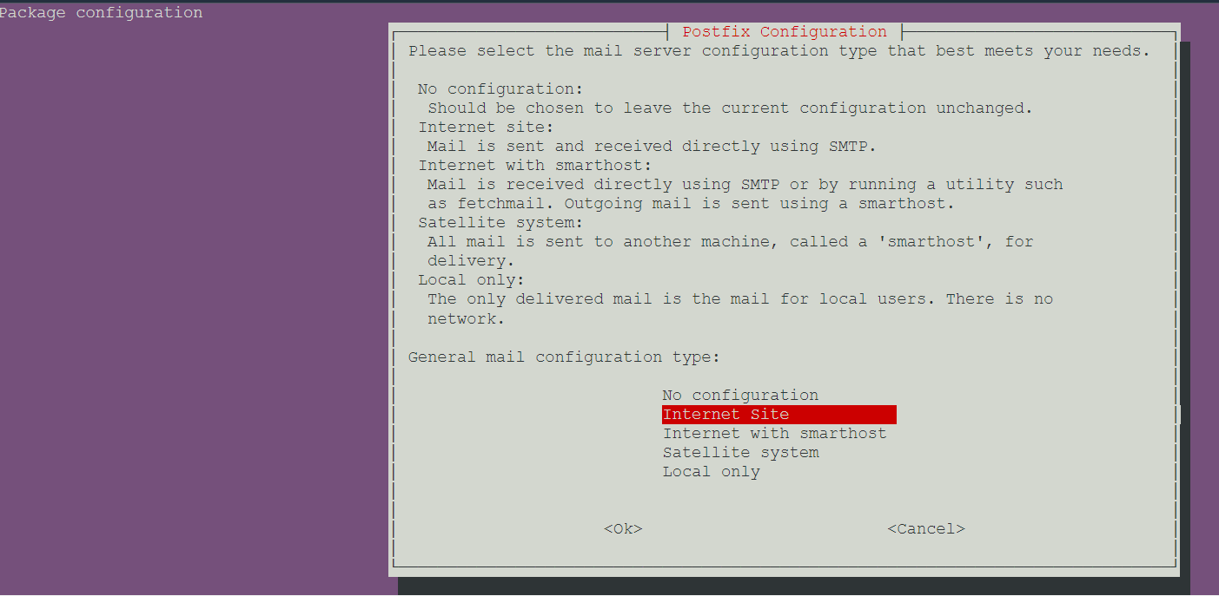

Enter OK

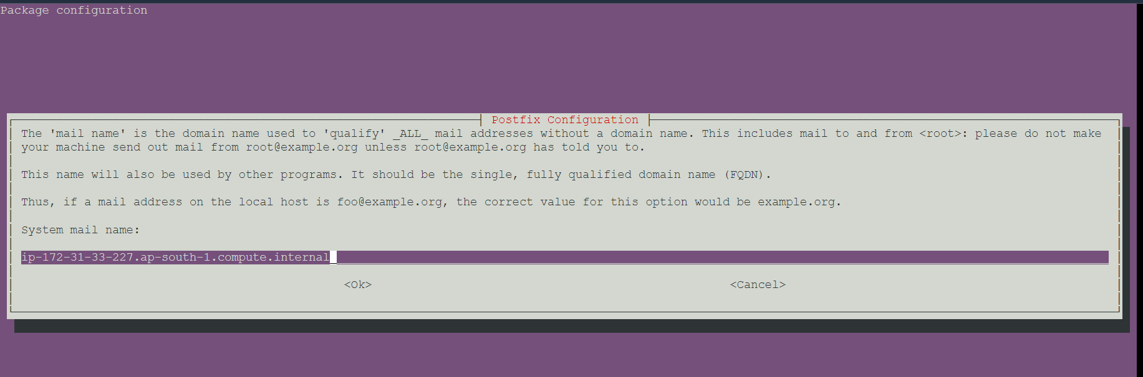

Enter OK

2. Add the GitLab package repository and install the package

* sudo curl https://packages.gitlab.com/install/repositories/gitlab/gitlab-ee/script.deb.sh | sudo bash

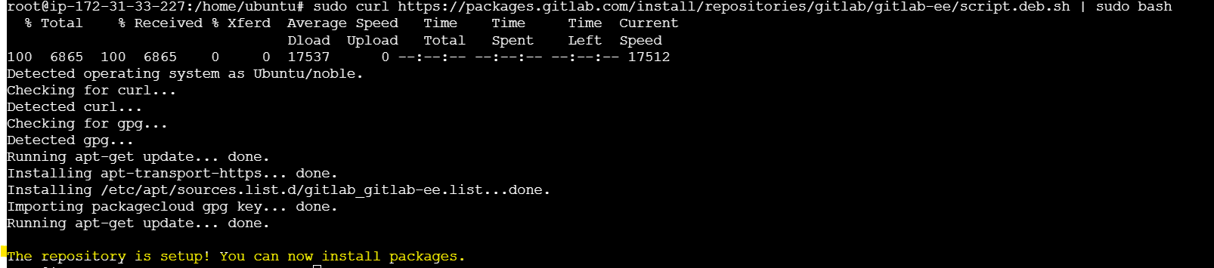

* sudo apt-get install gitlab-ee

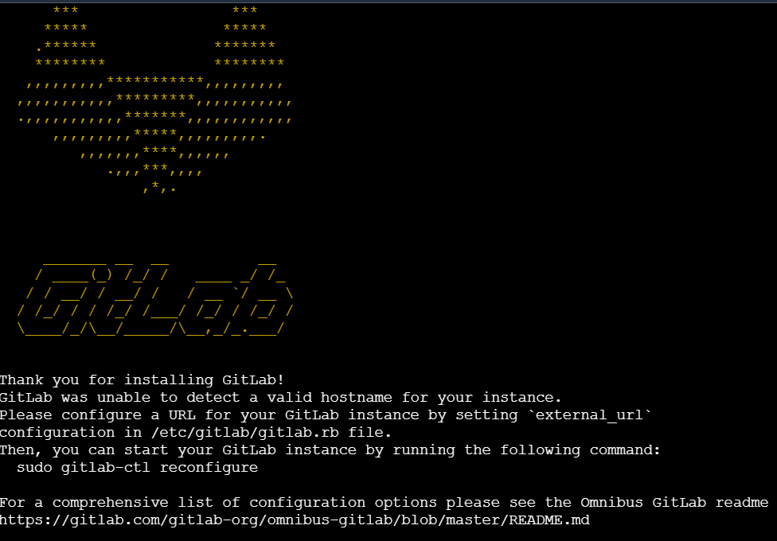

3. Browse to the hostname and login

Unless you provided a custom password during installation, a password will be randomly generated and stored for 24 hours in /etc/gitlab/initial_root_password. Use this password with username root to login.

4. Configuration.

* sudo vi /etc/gitlab/gitlag.rb
* change the external_url 'http://public IP'
* ifconfig

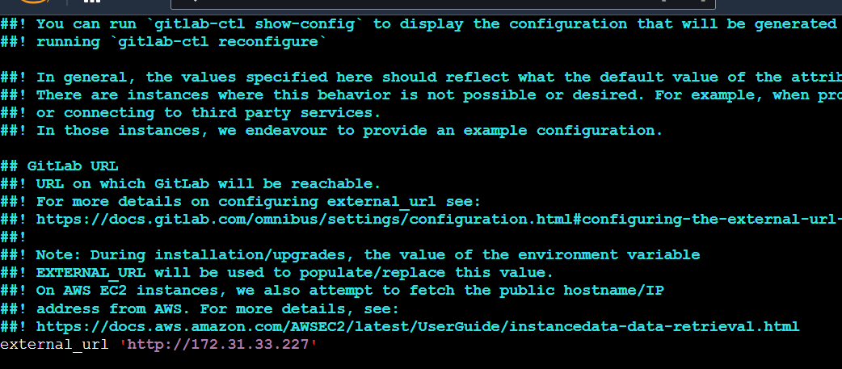

TO find the IP command is ifconfig

5. Enable fire-wall

* sudo ufw enable
* sudo ufw start
* sudo ufw status
* sudo ufw allow http
* sudo ufw allow https
* sudo ufw allow OpenSSH
* sudo ufw status

6. sudo gitlab-ctl reconfigure

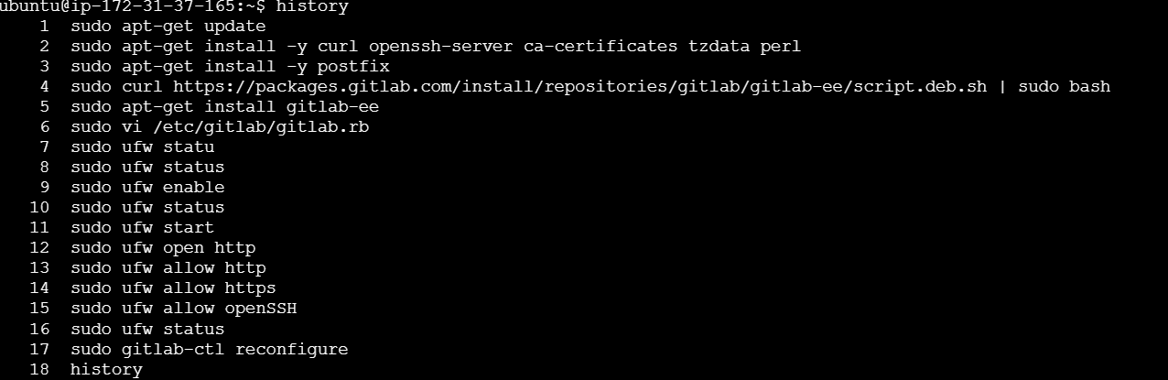

Installation and configuration is done

Copy the Public IP of instance and search in browser it will open the GitLab login page.

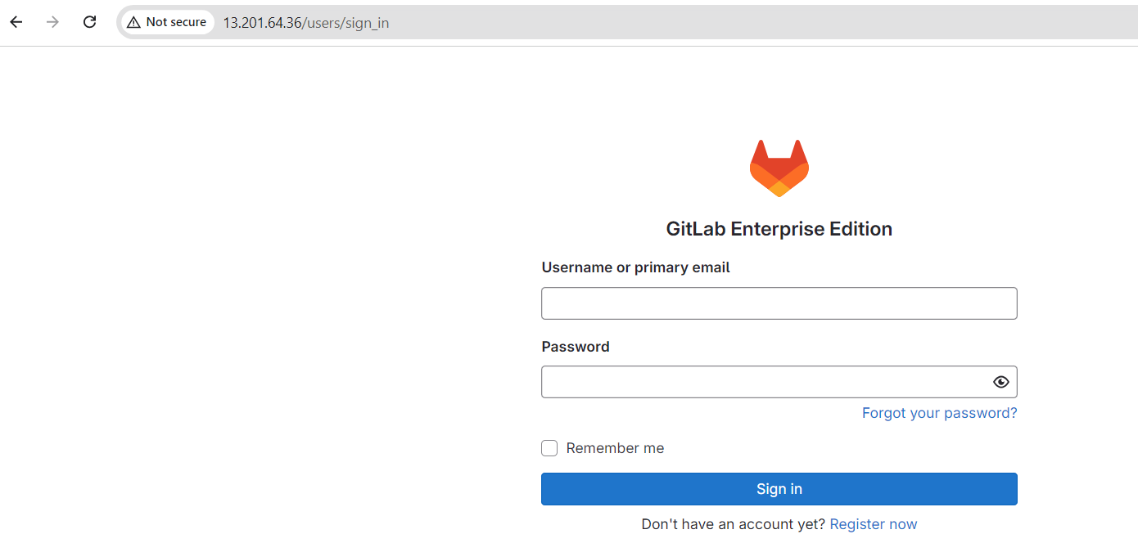

Username or primary email : root

Password:

autogenerated password will available in /etc/gitlab/initial_root_password

sudo vi /etc/gitlab/initial_root_password

Copy the password and paste and login.c

After logging into GitLab change the password.